**Semper Safe** [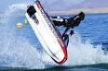](http://www.google.com/imgres?imgurl=http://ijbsa.bravehost.com/reef/jetski1.gif&imgrefurl=http://ijbsa.bravehost.com/&usg=__cgpBsKo-fJgBCmM08phGW0557Z8=&h=200&w=300&sz=46&hl=en&start=45&zoom=1&tbnid=FF5CvRaHhSDERM:&tbnh=77&tbnw=116&ei=TcMFUKaEGYPq9ASoudDpBw&prev=/search%3Fq%3Dwatercraft%2Bsafety%26start%3D42%26um%3D1%26hl%3Den%26sa%3DN%26gbv%3D2%26tbm%3Disch&um=1&itbs=1)

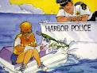

**Water Craft Safety – Fun in the Sun and Water**

Summertime is in full swing! Along with the beautiful North Carolina weather, miles and miles of beaches, rivers and lakes comes the enjoyment of boating. However, with this pleasure comes the possibility of injury or death, especially when mixed with alcohol.

The number of boats and personal watercrafts are increasing each year but the number of accidents and fatalities are decreasing due to boating being conducted safely and in accordance with state laws. Here are a few tips to help you enjoy your watercraft activities safely and keep you in compliance with state regulations:

* Learn to Swim. The best thing anyone can do to stay safe in and around water is to learn to swim. Sounds simple enough, but you would be surprised.
* Wear a Lifejacket. Most state laws require all vessels to have at least one Coast Guard approved, serviceable, properly sized flotation device for each person on board. Size is important as well, be sure it fits the person.
* 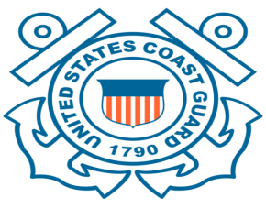Attend a Boating Safety Course. Courses are available online and within the local community. In addition, N.C. General Statutes require that anyone between the age of 14 and 26 years of age complete an approved Boating Education Course and carry a certification card and proof of age in order to operate a personal watercraft on the waters of North Carolina.
* Don’t Drink and Boat. NC law prohibits anyone from operating a watercraft while under the influence of alcohol or drugs. Alcohol and drugs cause impaired balance, blurred vision, poor coordination, impaired judgment, and slower reaction time.

**Boaters and Jet Skiers:** It is your responsibility to ensure that you conduct your watercraft activities safely. Remember that you are not the only one out there. Share the waters, have fun and enjoy the summer.

***As Marines, Sailors and Civil Servants we live by our core values. So think before you jeopardize the safety of yourself, your fellow Marines, Sailors, civilian employees or***

***family members, and remember SEMPER SAFE!***

SS 12-06

**Semper Safe**

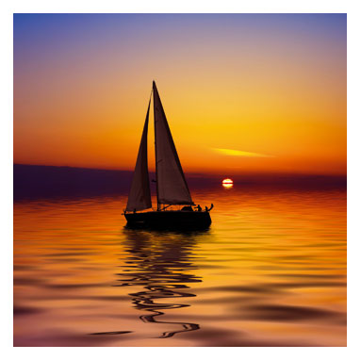

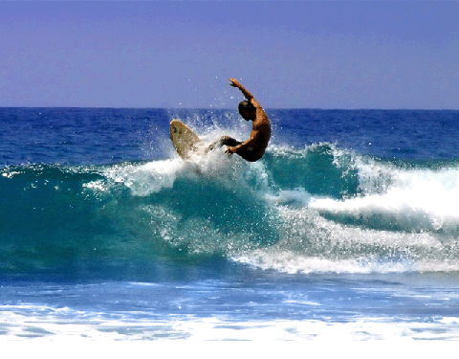

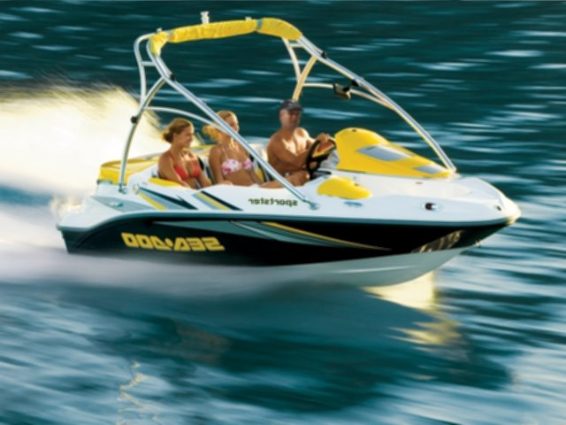

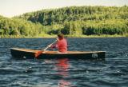

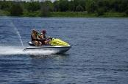

***As Marines, Sailors and Civil Servants we live by our core values. So think before you jeopardize the safety of yourself, your fellow Marines, Sailors, civilian employees or***

***family members, and remember SEMPER SAFE!***

SS 12-06